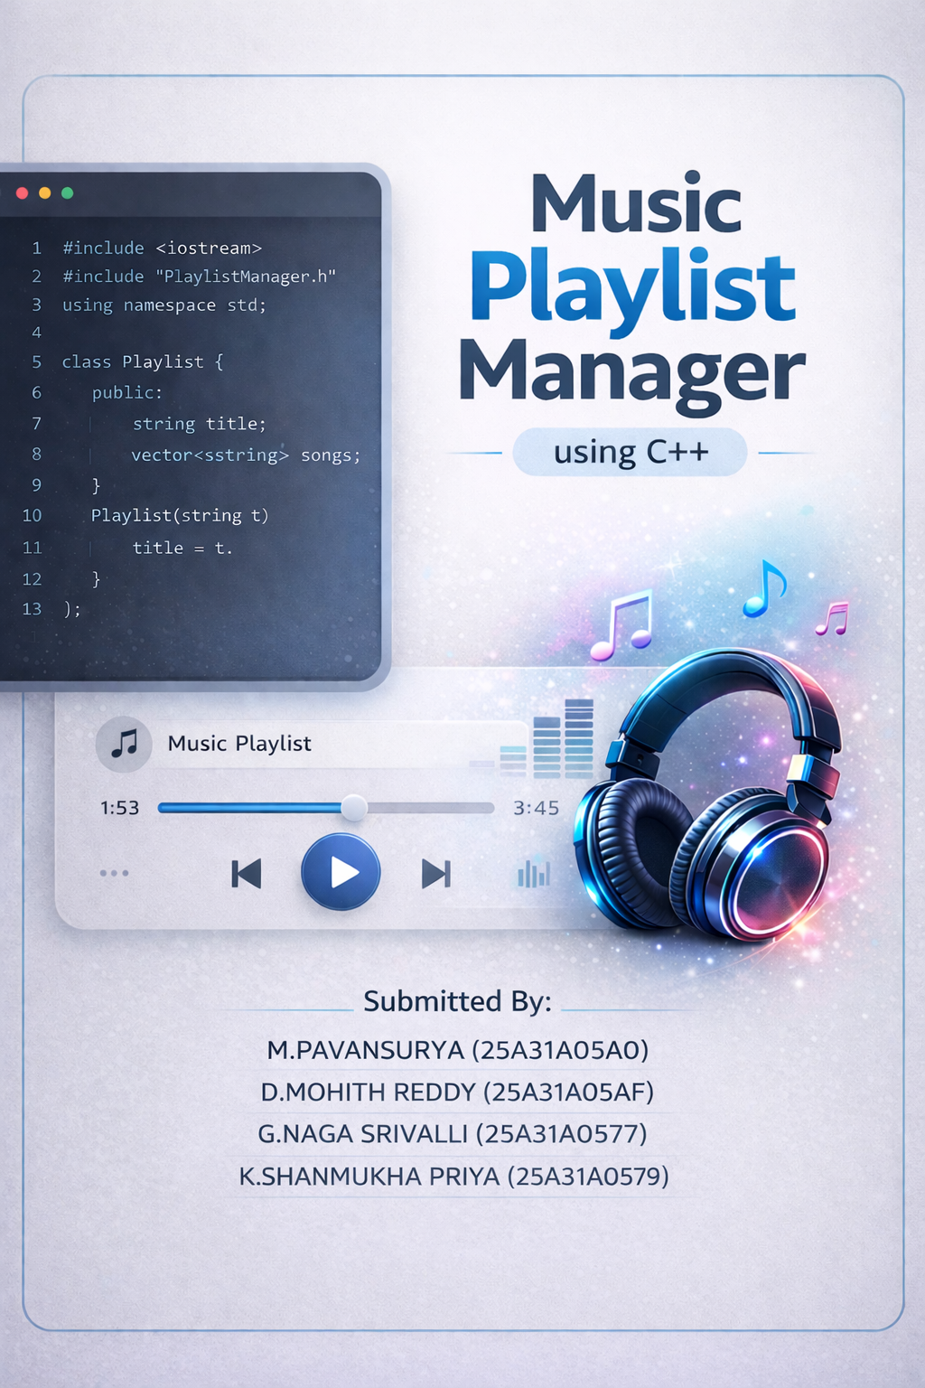
Introduction:
- A playlist is a collection of songs
- Music apps need efficient navigation
- Data structures help manage songs dynamically
- This project uses Circular Doubly Linked List
Objectives:
- To manage songs efficiently
- To enable forward and backward navigation
- To implement continuous playback
- To add advanced features like shuffle and repeat
Data Structure Used:
Circular Doubly Linked List (CDLL)
- Each node has:
  - Data (song name)
  - Next pointer
  - Previous pointer
- Last node connects to first node

CDLL Structure:
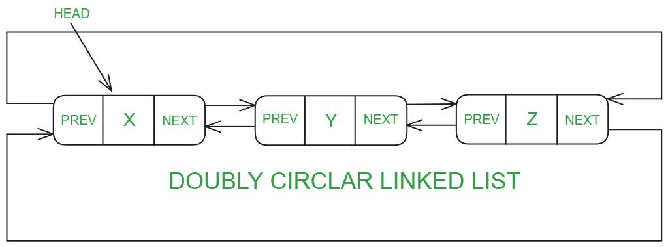
class Node {
string song;
Node* next;
Node* prev;
};
- Represents each song
- Stores links to next and previous songs
Working Principle:
- Songs are stored as nodes
- head → first song
- current → currently playing song
- Circular connection enables infinite looping

Add Song Operation:
- Create new node
- If empty:
  - Make it head
- Else:
  - Insert between tail and head
- Maintain circular links

Play Operations:
- Play Current Song
- Next Song → move to next node
- Previous Song → move to previous node
Advanced Features:
- Shuffle Play (random song)
- Repeat Song
- Recently Played Songs
- Save & Load Playlist
File Handling:
- Save playlist into file
- Load playlist from file
- Makes system reusable

Algorithm:
Circular Doubly Linked List Playlist Manager
Step-1:
Create Node
- Start
- Define a node with:
  - song (data)
  - next pointer
  - prev pointer
Step 2:
Initialize Playlist
- Start
- Set head = NULL
- Set current = NULL

Step 3:
Add Song
- Start
- Create a new node with given song name
- If head == NULL:
  - Set head = new node
  - Set head->next = head
  - Set head->prev = head
  - Set current = head
- Else:
  - Find last node: tail = head->prev
  - Set tail->next = new node
  - Set new node->prev = tail
  - Set new node->next = head
  - Set head->prev = new node
- Print "Song added"
- Stop

Step 4:
Display Playlist:
- Start
- If head == NULL, print "Playlist empty" and Stop
- Set temp = head
- Repeat:
  - Print temp->song
  - Move temp = temp->next
  - Until temp == head
Step 5:
Play Current Song
- Start
- If current == NULL, print "No song" and Stop
- Print current->song
- Store song in recent list
- Stop
Step 6:
Play Next Song
- Start
- If current != NULL:
  - Set current = current->next
Call Play Current Song

Step 7:
Play Previous Song
- Start
- If current != NULL:
  - Set current = current->prev
  - Call Play Current Song
Step 8:
Shuffle Play
- Start
- If head == NULL, Stop
- Count number of nodes in list
- Generate random number r
- Set temp = head
- Move temp forward r times
- Set current = temp
- Play current song
Step 9:
Repeat Song
- Start
- If current != NULL:
  - Play current song again
Step 10:
Recently Played Songs
- Start
- Store each played song in a list
- Display last 5 songs from list

Step 11:
Save Playlist to File
- Start
- Open file in write mode
- If head == NULL, Stop
- Traverse list from head
- Write each song into file
- Close file

Step 12:
Load Playlist from File
- Start
- Open file in read mode
- Read each line (song name)
- Call Add Song for each
- Close file

Step 13:
Main Menu
- Start
- Repeat until user exits:
  - Display menu options
  - Read user choice
  - Call corresponding function
- Stop

